
Programming fundamentals
Assignment 2
Name:
Noor-ul-ain-khan
Registration number:
FA25-BDS-039
Assignment :
Programming fundamentals - 2
Date:
11-October-2025
Submitted to:
Mr.Khurram Iqbal

Table of contents
Q1 – Social Security Number Validation
Q2 – Student Major and Year
Q3 – Vehicle Plate Generator
Q4 – Decimal to Binary Conversion
Q5 – Global Warming Quiz

Question 1
Social security number validation
Write a program that prompts the user to enter a Social Security number in the format DDD-DD-DDDD, where D is a digit. Your program should check whether the input is valid. Here are sample runs:
Enter a SSN: 232-23-5435
232-23-5435 is a valid social security number
Enter a SSN: 23-23-5435
23-23-5435 is an invalid social security number

Solution
import java.util.Scanner;
public class Program1 {
public static void main(String[] args) {
Scanner sc = new Scanner(System.in);
System.out.print("Enter a SSN: ");
String ssn = sc.nextLine().trim();

if (isValidSSN(ssn)) {
System.out.println(ssn + " is a valid social security number");
} else {
System.out.println(ssn + " is an invalid social security number");
}
sc.close();
}

static boolean isValidSSN(String s) {
if (s == null) return false;
return s.matches("\\d{3}-\\d{2}-\\d{4}");
}
}
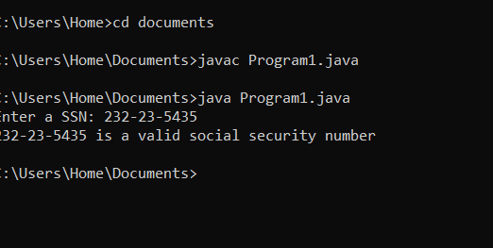

Question 2
Student subjects
Write a program that prompts the user to enter two characters and displays the major and status represented in the characters. The first character indicates the major and the second is number character 1, 2, 3, 4, which indicates whether a student is a freshman, sophomore, junior, or senior. Suppose the following characters are used to denote the majors:
M: Mathematics C: Computer Science I: Information Technology
Solution
import java.util.Scanner;
public class Program2 {
public static void main(String[] args) {
Scanner sc = new Scanner(System.in);
System.out.print("Enter two characters (e.g. M1): ");
String input = sc.nextLine().trim();

if (input.length() != 2) {
System.out.println("Invalid input — must be 2 characters.");
} else {
char major = Character.toUpperCase(input.charAt(0));
char level = input.charAt(1);
String majorName = null, yearName = null;

switch (major) {
case 'M': majorName = "Mathematics"; break;
case 'C': majorName = "Computer Science"; break;
case 'I': majorName = "Information Technology"; break;
}
switch (level) {
case '1': yearName = "Freshman"; break;
case '2': yearName = "Sophomore"; break;
case '3': yearName = "Junior"; break;
case '4': yearName = "Senior"; break;
}

if (majorName == null || yearName == null)
System.out.println("Invalid input.");
else
System.out.println(majorName + " " + yearName);
}
sc.close();
}
}
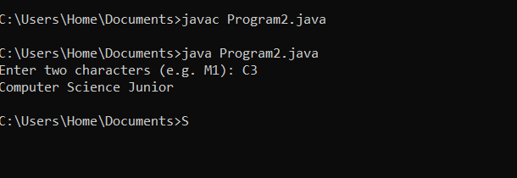

Program 3 — Vehicle Plate Generator
Assume a vehicle plate number consists of three uppercase letters followed by four digits. Write a program to generate a plate number
Solution.
import java.util.Random;
public class Program3 {
public static void main(String[] args) {
Random rnd = new Random();
String plate = generatePlate(rnd);
System.out.println("Generated plate number: " + plate);
}

static String generatePlate(Random rnd) {
StringBuilder sb = new StringBuilder();
for (int i = 0; i < 3; i++) {
char ch = (char) ('A' + rnd.nextInt(26));
sb.append(ch);
}
for (int i = 0; i < 4; i++) {
sb.append(rnd.nextInt(10));
}
return sb.toString();
}
}
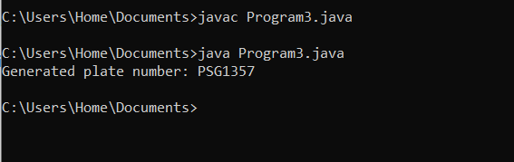

Program 4 — Decimal to Binary Conversion
Write a program that prompts the user to enter a decimal integer and displays its corresponding binary value. Don’t use Java’s Integer.toBinaryString(int) in this program.
import java.util.Scanner;

// Program 4: Decimal to Binary Converter
// Converts any integer to binary form without using Integer.toBinaryString()
public class Program4 {
public static void main(String[] args) {
Scanner sc = new Scanner(System.in);
System.out.print("Enter a decimal integer: ");
String input = sc.nextLine().trim();

try {
int number =sc.nextInt();
String binary = toBinary(number);
System.out.println("Binary value: " + binary);
} catch (NumberFormatException e) {
System.out.println("Invalid input — please enter an integer only.");
}

sc.close();
}

static String toBinary(int n) {
// Case 1: zero
if (n == 0) return "0";

// Case 2: positive number
if (n > 0) {
StringBuilder sb = new StringBuilder();
while (n > 0) {
sb.append(n % 2);
n /= 2;
}
return sb.reverse().toString();
}

// Case 3: negative number — manual 32-bit conversion
StringBuilder sb = new StringBuilder();
int mask = 1 << 31; // start with leftmost bit
for (int i = 0; i < 32; i++) {
sb.append((n & mask) == 0 ? '0' : '1');
mask >>>= 1; // logical right shift
}
return sb.toString();
}
}
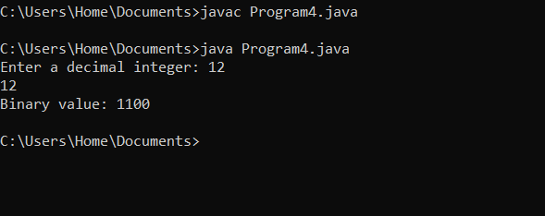

Program 5 — Global Warming Quiz
The controversial issue of global warming has been widely publicized by the film “An Inconvenient Truth,” featuring former Vice President Al Gore. Mr. Gore and a U.N. network of scientists, the Intergovernmental Panel on Climate Change, shared the 2007 Nobel Peace Prize in recognition of “their efforts to build up and disseminate greater knowledge about man-made climate change.” Research both sides of the global warming issue online (you might want to search for phrases like “global warming skeptics”). Create a five-question multiple choice quiz on global warming, each question having four possible answers (numbered 1–4). Be objective and try to fairly represent both sides of the issue. Next, write an application that administers the quiz, calculates the number of correct answers (zero through five) and returns a message to the user. If the user correctly answers five questions, print “Excellent”; if four, print “Very good”; if three or fewer, print “Time to brush up on your knowledge of global warming,” and include a list of some of the websites where you found your facts
solution
import java.util.Scanner;
public class Program5 {
static Scanner sc = new Scanner(System.in);

public static void main(String[] args) {
String[] questions = {
"1) Which gas is the primary driver of modern global warming?",
"2) Which organization produces assessment reports used by policymakers worldwide?",
"3) What is a common skeptical argument about climate change?",
"4) Which observation is widely cited as evidence of recent global warming?",
"5) If global average temperature rises 1.5–2°C above pre-industrial levels, major risks include:"
};

String[][] options = {
{"1) Oxygen (O2)", "2) Nitrogen (N2)", "3) Carbon dioxide (CO2)", "4) Argon (Ar)"},
{"1) WHO", "2) IPCC", "3) IMF", "4) WTO"},
{"1) Warming is caused by greenhouse gases", "2) Warming is caused by the Sun", "3) Warming proven by every scientist", "4) Warming cannot affect weather"},
{"1) Sea levels falling", "2) Arctic ice and glaciers shrinking", "3) More volcanoes", "4) Global temperature dropping"},
{"1) Minimal impact", "2) Crop loss, extreme weather, sea-level rise", "3) Only benefits", "4) No effects"}
};

int[] correct = {3, 2, 2, 2, 2};
int score = 0;

System.out.println("---- Global Warming Quiz ----");
for (int i = 0; i < questions.length; i++) {
System.out.println("\n" + questions[i]);
for (String opt : options[i]) System.out.println(opt);
int ans = getValidatedOption();
if (ans == correct[i]) score++;
}

System.out.println("\nYou scored: " + score + " / 5");
if (score == 5) System.out.println("Excellent!");
else if (score == 4) System.out.println("Very good!");
else System.out.println("Time to brush up on your climate knowledge.");

System.out.println("\nReferences: NASA, IPCC, SkepticalScience.org");
sc.close();
}

static int getValidatedOption() {
while (true) {
System.out.print("Enter your answer (1-4): ");
String s = sc.nextLine().trim();
if (s.matches("[1-4]")) return sc.nextInt();
System.out.println("Invalid choice! Please enter 1-4.");
}
}
}
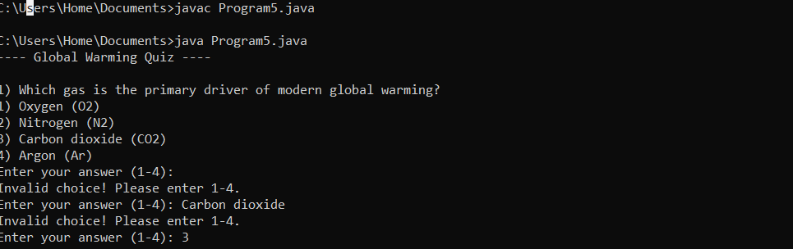

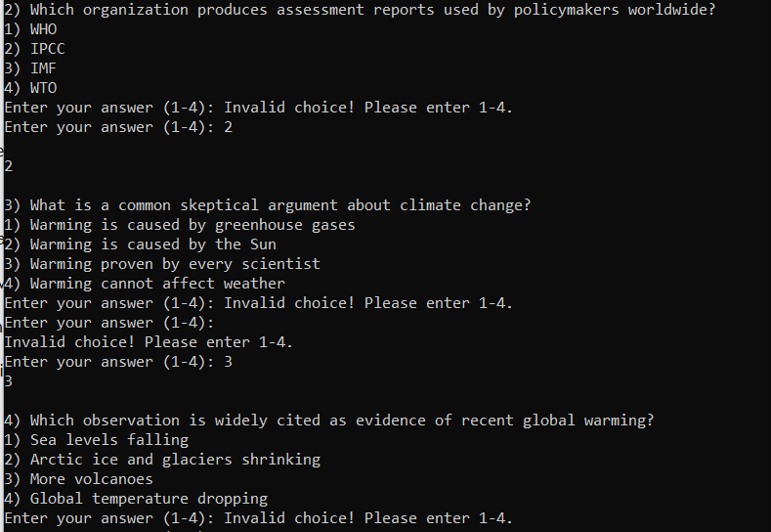

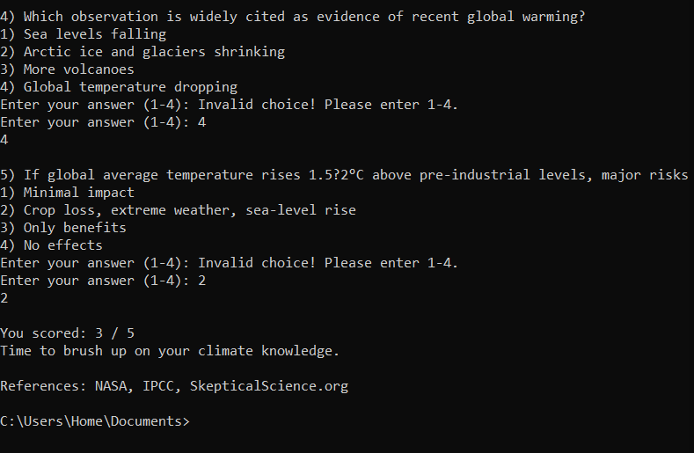

Refrences
- Nasa
- IPCC
- SkepticalScience

Combined codes
import java.util.Random;
import java.util.Scanner;

public class Assignment2 {
static Scanner sc = new Scanner(System.in);

public static void main(String[] args) {
while (true) {
printMainMenu();
String opt = sc.nextLine().trim();
if (opt.equals("0")) {
System.out.println("Exiting. Goodbye!");
break;
}
switch (opt) {
case "1": question1(); break;
case "2": question2(); break;
case "3": question3(); break;
case "4": question4(); break;
case "5": question5(); break;
default:
System.out.println("Invalid option. Please enter 0-5.");
}
}
sc.close();
}

static void printMainMenu() {
System.out.println("\n---Main Menu (Assignment-2)-------");
System.out.println("1 – Question-1");
System.out.println("2 – Question-2");
System.out.println("3 – Question-3");
System.out.println("4 – Question-4");
System.out.println("5 – Question-5");
System.out.println("Press option (1-5) to execute the program and Press 0 to Exit");
System.out.print("Enter your option: ");
}

// ---------- Question 1 ----------
static void question1() {
while (true) {
System.out.println("\n---Executing Question – 1-------");
System.out.print("Enter a SSN: ");
String ssn = sc.nextLine().trim();
if (isValidSSN(ssn)) {
System.out.println(ssn + " is a valid social security number");
} else {
System.out.println(ssn + " is an invalid social security number");
}
if (!repeatOrBack()) return;
}
}

static boolean isValidSSN(String s) {
if (s == null) return false;
// pattern DDD-DD-DDDD (digits only except dashes)
return s.matches("\\d{3}-\\d{2}-\\d{4}");
}

// ---------- Question 2 ----------
static void question2() {
while (true) {
System.out.println("\n---Executing Question – 2-------");
System.out.print("Enter two characters (e.g. M1): ");
String in = sc.nextLine().trim();
if (in.length() != 2) {
System.out.println("Invalid input");
} else {
char major = Character.toUpperCase(in.charAt(0));
char level = in.charAt(1);
String majorName = "";
switch (major) {
case 'M': majorName = "Mathematics"; break;
case 'C': majorName = "Computer Science"; break;
case 'I': majorName = "Information Technology"; break;
default: majorName = null;
}
String year = null;
switch (level) {
case '1': year = "Freshman"; break;
case '2': year = "Sophomore"; break;
case '3': year = "Junior"; break;
case '4': year = "Senior"; break;
}
if (majorName == null || year == null) {
System.out.println("Invalid input");
} else {
System.out.println(majorName + " " + year);
}
}
if (!repeatOrBack()) return;
}
}

// ---------- Question 3 ----------
static void question3() {
Random rnd = new Random();
while (true) {
System.out.println("\n---Executing Question – 3-------");
String plate = generatePlate(rnd);
System.out.println("Generated plate number: " + plate);
if (!repeatOrBack()) return;
}
}

static String generatePlate(Random rnd) {
StringBuilder sb = new StringBuilder();
for (int i = 0; i < 3; i++) {
char ch = (char) ('A' + rnd.nextInt(26));
sb.append(ch);
}
for (int i = 0; i < 4; i++) {
sb.append(rnd.nextInt(10));
}
return sb.toString();
}

// ---------- Question 4 ----------
static void question4() {
while (true) {
System.out.println("\n---Executing Question – 4-------");
System.out.print("Enter a decimal integer: ");
String line = sc.nextLine().trim();
try {
int n = Integer.parseInt(line);
System.out.println("Binary value: " + toBinary(n));
} catch (NumberFormatException ex) {
System.out.println("Invalid integer input.");
}
if (!repeatOrBack()) return;
}
}

static String toBinary(int n) {
if (n == 0) return "0";
boolean neg = n < 0;
// For negative numbers, convert to two's complement 32-bit representation:
if (neg) {
// Represent as unsigned 32-bit binary for negative numbers
StringBuilder sb = new StringBuilder();
for (int i = 31; i >= 0; i--) {
sb.append(((n >>> i) & 1) == 1 ? '1' : '0');
}
// trim leading zeros (keep at least one bit)
int firstOne = sb.indexOf("1");
return sb.substring(firstOne >= 0 ? firstOne : sb.length() - 1);
} else {
StringBuilder sb = new StringBuilder();
while (n > 0) {
sb.append(n % 2);
n /= 2;
}
return sb.reverse().toString();
}
}

// ---------- Question 5 ----------
static void question5() {
// Quiz questions (5 MCQs). Each question has 4 options; correctAnswers stores index (1-4).
String[] questions = {
"1) Which gas is the primary driver of modern global warming?",
"2) Which organization produces comprehensive assessment reports used by policymakers worldwide?",
"3) What is a common skeptical argument about climate change?",
"4) Which observation is widely cited as evidence of recent global warming?",
"5) If global average temperature rises ~1.5–2°C above pre-industrial levels, major risks include:"
};
String[][] options = {
{"1) Oxygen (O2)", "2) Nitrogen (N2)", "3) Carbon dioxide (CO2)", "4) Argon (Ar)"},
{"1) World Health Organization (WHO)", "2) Intergovernmental Panel on Climate Change (IPCC)", "3) International Monetary Fund (IMF)", "4) World Trade Organization (WTO)"},
{"1) Warming is mostly caused by increases in greenhouse gases", "2) Warming is primarily caused by changes in the Sun", "3) Warming is proven beyond dispute by every single scientist", "4) Warming cannot change global weather patterns"},
{"1) Global sea levels falling", "2) Rapid decline in Arctic sea ice and shrinking glaciers", "3) Increase in volcanic activity worldwide", "4) Global average temperature dropping steadily for 50 years"},
{"1) Minimal impact only on polar bears", "2) Declines in crop yield, more extreme weather, sea-level rise threatening coastal populations", "3) Only benefits (longer growing seasons) everywhere", "4) No measurable effects"}
};
int[] correct = {3, 2, 2, 2, 2}; // correct option numbers

while (true) {
System.out.println("\n---Executing Question – 5 (Global Warming Quiz)-------");
System.out.println("Answer the five multiple choice questions (1-4).");
int score = 0;
for (int i = 0; i < questions.length; i++) {
System.out.println("\n" + questions[i]);
for (String opt : options[i]) System.out.println(opt);
int ans = getValidatedOption();
if (ans == correct[i]) score++;
}
System.out.println("\nYou scored: " + score + " / 5");
if (score == 5) System.out.println("Excellent");
else if (score == 4) System.out.println("Very good");
else System.out.println("Time to brush up on your knowledge of global warming.");
System.out.println("\nReferences and further reading used to prepare these questions:");
System.out.println(" - NASA: Evidence for climate change and scientific consensus.");
System.out.println(" - SkepticalScience: common skeptical arguments and rebuttals.");
System.out.println(" - IPCC / Nobel coverage on efforts to disseminate knowledge.");
System.out.println("See listed URLs in the assignment report (or instructor slide).");
if (!repeatOrBack()) return;
}
}

static int getValidatedOption() {
while (true) {
System.out.print("Enter your answer (1-4): ");
String s = sc.nextLine().trim();
if (s.matches("[1-4]")) {
return Integer.parseInt(s);
}
System.out.println("Please enter a number from 1 to 4.");
}
}

// ---------- Navigation helper ----------
// Returns true if user wants to repeat the same question; false to go back to main menu
static boolean repeatOrBack() {
while (true) {
System.out.println("\nDo you want to Execute this question again then press (y) Otherwise Press 0 (b) to go to the main menu");
System.out.print("Enter your Option: ");
String o = sc.nextLine().trim().toLowerCase();
if (o.equals("y")) return true;
if (o.equals("b") || o.equals("0")) return false;
System.out.println("Invalid choice. Enter 'y' to repeat or 'b' (or 0) to go back to main menu.");
}
}
}

Assignment ended

